<https://www.tutorialspoint.com/arduino/arduino_dc_motor.htm>

<https://www.instructables.com/id/INTERFACING-MOTOR-WITH-ARDUINO/>

<https://www.instructables.com/id/Controlling-Brushless-Motor-With-Arduino/>

<https://www.bc-robotics.com/tutorials/controlling-dc-motor-arduino/>

<https://forum.arduino.cc/index.php?topic=367100.0>

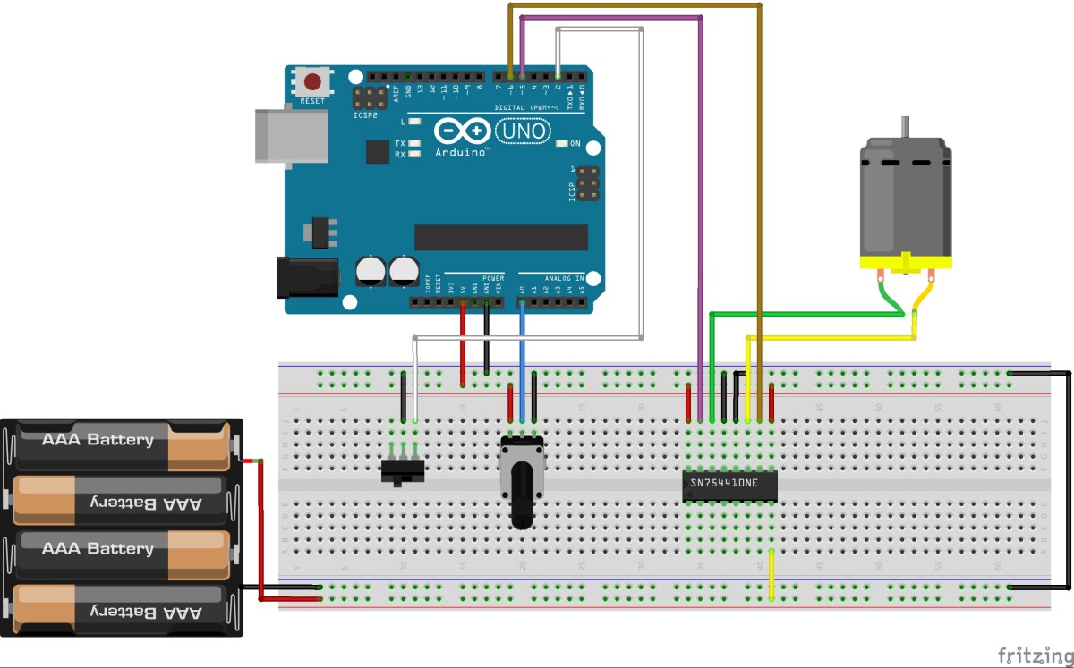

|  |  |  |
| --- | --- | --- |
| IN1 | IN2 | FUNCTION |
|  |  | BRAKE |
| 1 |  | FORWARD |
|  | 1 | BACKWARD |
| 1 | 1 | BRAKE |

Remove the pentoimeter (speed controller) and direction switch (sound input sensor)

# [SN754410 x L298?](https://forum.pololu.com/t/sn754410-x-l298/855)

<https://forum.pololu.com/t/sn754410-x-l298/855>